

MSc Data Science Project
7PAM2002
Department of Physics, Astronomy and Mathematics

Data Science FINAL PROJECT REPORT

Project Title:
Automated Diagnosis of Coronary Heart Disease Using Machine Learning Classification

Student Name and SRN:
Hafiz Usman Javed
24065098
Supervisor: Aoife Simpson
Date Submitted: 22 April 2026
GitHub Link:
Word Count: 5540

DECLARATION STATEMENT
This report is submitted in partial fulfilment of the requirement for the degree of Master of Science in Data Science at the University of Hertfordshire.
I have read the detailed guidance to students on academic integrity, misconduct and plagiarism information at Assessment Offences and Academic Misconduct and understand the University process of dealing with suspected cases of academic misconduct and the possible penalties, which could include failing the project or course.
I certify that the work submitted is my own and that any material derived or quoted from published or unpublished work of other persons has been duly acknowledged. (Ref. UPR AS/C/6.1, section 7 and UPR AS/C/5, section 3.6)
I did not use human participants in my MSc Project.

I hereby give permission for the report to be made available on module websites provided the source is acknowledged.

Student Name printed:
Hafiz Usman Javed
Student Name signature
Usman
Student SRN number:
24065098

SCHOOL OF PHYSICS, ENGINEERING AND COMPUTER SCIENCE
Abstract
This study examines machine learning methods for coronary heart disease prediction through clinical data analysis. The research aims to identify the most effective classification algorithm and the most influential clinical indicators for disease prediction. The study used the Heart Disease dataset from the UCI Machine Learning Repository which contains 920 patient records and 14 clinical attributes including chest pain type and cholesterol level and ST depression. The researchers developed Logistic Regression and Random Forest and Support Vector Machine models which included SMOTE balancing and hyper parameter optimization. The optimized SVM achieved the highest performance with 86.41% accuracy and 0.9314 recall. The results show that machine learning models can successfully assist in the early detection of coronary heart disease.

Contents
Chapter 1 Introduction 1
1.1 Overview 1
1.2 Contextual Overview 1
1.3 Current Market Practice 1
1.4 Problem Statement 1
1.5 Aim and Purpose 1
1.6 Objectives 2
1.7 Research Questions (RQ) 2
1.8 Structure of the Report 2
Chapter 2 Background 3
2.1 Background Overview 3
2.2 Literature Review 3
2.3 Literature Review and Research Gap. 4
Chapter 3 Dataset 5
3.1 Dataset Source & Collection 5
3.2 Dataset Details 5
3.3 Reason for Selecting the Dataset 6
3.4 Data Loading, Missing Value Analysis, and Imputation 6
3.5 Exploratory Data Analysis (EDA) 6
Chapter 4 Ethical Consideration 9
4.1 Data Privacy and Anonymization 9
4.2 Data Usage and Licensing 9
4.3 Ethical Approval and General Data Protection Regulation 9
4.4 Ethical Data Collection 9
Chapter 5 Methodology 10
5.1 Overview of the Chapter 10
5.2 Train-Test Data Split 10
5.3 Feature Scaling 10
5.4 Machine Learning Models 10
5.4.1 Logistic Regression 10
5.4.2 Random Forest 10
5.4.3 Support Vector Machine (SVM). 11
5.5 Handling Class Imbalance 11
5.6 Hyperparameter Optimization 11
5.7 Binary and Multi-Class Classification 12
5.8 Model Evaluation Metrics 12
5.9 Cross-Validation 13
5.10 Feature Importance Analysis 13
Chapter 6 Results 14
6.1 Overview of the Chapter 14
6.2 Multi-Class Model Performance (Severity Prediction) 14
6.3 After Data Balancing the Multi-Class Performance Assessment 14
6.4 Optimized Binary Classification Model Performance 15
6.5 Confusion Matrix Analysis 15
6.6 Feature Importance Analysis 17
6.7 Discussion of Research Questions 18
6.8 Practical Applicability of the Study 18
Chapter 7 Analysis and Discussion 19
7.1 Interpretation of Results 19
7.2 Model Performance Analysis 19
7.3 Comparison with Previous Studies 19
7.4 Relation to RQ 20
7.5 Limitations and Practical Implications 20
Chapter 8 Conclusion 21
Chapter 9 References 22
Chapter 10 Appendix 23

Introduction

Overview
Coronary Heart Disease (CHD) is considered to be one of the major causes of deaths worldwide. Detection of CHD Disease at an early stage to ensure effective treatment. Machine learning (ML) techniques are being used to develop intelligent systems to analyze clinical data to support diagnostic decision-making processes. This will help for accurate and speedily diagnostic process to identify patients at greater risk (Çakmak et al., 2026; Hassan et al., 2022)

Contextual Overview
The rapid growth of healthcare data provides new opportunities to utilize machine learning techniques to support disease diagnosis (Çakmak et al., 2026). The Coronavirus Heart Disease prediction model will be able to analyze clinical indicators such as cholesterol levels, types of chest pain, and blood pressure to identify patterns of the disease. The recent study shows that machine learning techniques such as k-Nearest Neighbours(k-NN), Support Vector Machine (SVM), and neural network are capable of achieving high accuracy to diagnose coronary artery disease (Zhao et al., 2026)

Current Market Practice
The current healthcare practice utilizes intelligent diagnostic tools to support decision-making processes (Zhao et al., 2026). Machine learning techniques are being integrated into hospital information systems to support early cardiovascular risk detection (Amini et al., 2023)

Problem Statement
The accurate and timely diagnosis of CHD using conventional methods has been challenging. The conventional diagnostic methods involve interpreting the results of clinical tests and images, which might cause delays in the diagnostic process. Moreover, the conventional methods might not be effective in identifying the most influential features to support the diagnostic process. It is therefore important to develop intelligent systems to accurately detect CHD with ML classification techniques to identify the most influential features (Hassan et al., 2022; Zhao et al., 2026)

Aim and Purpose
Aim:
Design an automatic machine learning classification system to diagnose Coronary Heart Disease using clinical data.

Purpose:
Assess the efficacy of ML technique in identifying CHD and determining key clinical factors that contribute to CHD.

Objectives
- To Design machine learning classification models to automatically diagnose coronary heart disease.
- To assess the effectiveness of various algorithms according to sensitivity, accuracy, and area under the curve.
- To identify key clinical factors that contribute to CHD prediction.
- To investigate binary and multi-class classification models in disease diagnosis.

Research Questions (RQ)
- RQ1: Which classification algorithm achieves the highest sensitivity for detecting the presence of heart disease?
- RQ2: Which feature plays a main role in prediction of the diagnosis that are present in the dataset?
- RQ3: How does the performance changes if we shift from multi-class to binary class?

Structure of the Report
Chapter 1 is for the introduction of topic. Chapter 2 is for discussing works related to ML in diagnosis of CHD. Chapter 3 is for discussing the data set and data characteristics. Chapter 4 is for discussing ethical considerations. Chapter 5 is for discussing the methodology and machine learning models. Chapter 6 is for discussing experimental results. Chapter 7 is for discussing analysis and results interpretation. Chapter 8 is for discussing conclusions and recommendations. Chapter 9 is for listing the references used in this research.

Background

Background Overview
The present chapter is dedicated to the past studies done on the use of machine learning methods to diagnose and predict coronary heart diseases. It also presents some of the recent researches that have been carried out on the implementation of machine learning methods using clinical, behavioral and medical imaging data to predict coronary heart diseases.

Literature Review
As recent literature has shown, machine learning methods have proven to be efficient in predicting coronary heart disease, and the common theme is the need to enhance diagnostic accuracy by means of the selection of algorithms, and feature engineering of the model. Both Tasmurzayev et al. (2025) and Sayadi et al. (2022) were using the Z-Alizadeh Sani dataset, which makes it possible to directly compare the approaches. Tasmurzayev et al. (2025) have indicated that XGBoost was best with accuracy of 90.11 percent and an AUC of 0.92, using Shapley Additive explanations (SHAP) analysis to determine the main predictors of hypertension, valvular heart disease, and diabetes, Sayadi et al. (2022) have shown that logistic regression and SVM This analogy brings to light one important point that is common to both studies, namely, that feature selection and model interpretability can be as effective as algorithm choice in producing a good diagnostic performance.
Based on this theme, Ogunpola et al. (2024) and Chen et al. (2025) further established how ensemble and hybrid feature selection strategies could be used to push the performance boundaries. Ogunpola et al. (2024) have provided a wide analysis of such models as K-NN, SVM, logistic regression, random forests, Convolutional Neural Network (CNN), gradient boost, and Extreme Gradient Boosting (XGBoost)s, in particular, the issues of class imbalance that are often neglected in previous research. Their XGBoost model had a high precision and recall of 98.50% which supports the observation that the ensemble method always performs better than the simpler classifiers as stated by Tasmurzayev et al. (2025). Chen et al. (2025) furthered this research by training Least Absolute Shrinkage and Selection Operator (LASSO), logistic regression (LR), and recursive feature elimination on a more localized patient population, which includes patients who have both coronary heart disease and type-2 diabetes, to select features before training SVM, random forest, XGBoost, and LightGBM models. Their optimal model had AUC of 0.814 which indicates that machine learning is still effective even in complex, comorbid clinical cases where interactions between features are more complicated.
Collectively, these four studies demonstrate a definite advance in the area. Earlier work has been mostly concerned with accuracy maximization by selecting algorithms, whereas more recent works have been concerned with interpretability, feature selection, and addressing data issues such as class imbalance and comorbidities. XGBoost is a reliable and robust performer in all studies, and tools like SHAP are becoming seen as necessary to establish clinical confidence in model predictions.

Literature Review and Research Gap.
The research studies reviewed show that it is possible to attain high accuracy using modern methods such as XGBoost, SVM, Logistic Regression, and Random Forest to forecast coronary heart disease. Additionally, one can find numerous research studies indicating the importance of feature selection and interpretable Artificial Intelligence (AI)models like SHAP to achieve a higher model interpretability. Nevertheless, there are constraints in the studies reviewed. Numerous models rely on the particular data sets and clinical characteristics which restrict generalization. Moreover, the majority of studies concentrate more on accuracy, instead of investigating alternative classification methods like binary and multi-class classification to predict the severity of coronary heart disease.
More research needs to be conducted to develop automated machine learning classification models that not only attain better accuracy but also identify the most significant clinical indicators to forecast coronary heart disease using different classification models.

Dataset

Dataset Source & Collection
The study used Heart Disease Dataset which researchers obtained from the UCI Machine Learning Repository.
Researchers collected data from multiple hospitals to assist their studies on diagnosing coronary artery disease (CAD). The researchers collected data from Cleveland Clinic Foundation (USA), Hungarian Institute of Cardiology (Hungary), University Hospital Zurich (Switzerland), and VA Medical Center Long Beach (USA).
The dataset contains clinical measurements of patients who underwent medical examination for heart disease. The researchers collected demographic data and clinical symptoms together with laboratory test results to investigate factors that contribute to coronary heart disease while developing better diagnosis techniques.
The Cleveland dataset stands as the preferred subset because it provides complete clinical data which researchers can use to analyze multiple medical characteristics.

Dataset Details
The combined dataset contains 920 patient records and 14 attributes (plus a region identifier column). Table 3.1 shows the variables and description of features including target variable.
Table 3.1 Key Dataset Attributes
# | Variable | Description
1 | age | Patient's age in years
2 | sex | Gender (1 = Male, 0 = Female)
3 | cp | Chest pain type (1–4)
4 | trestbps | Resting blood pressure (mm Hg)
5 | chol | Serum cholesterol (mg/dl)
6 | fbs | Fasting blood sugar > 120 mg/dl
7 | restecg | Resting Electrocardiogram (ECG) results
8 | thalach | Maximum heart rate achieved
9 | exang | Exercise induced angina
10 | oldpeak | ST depression during exercise
11 | slope | Slope of peak exercise ST segment
12 | ca | Number of major vessels (0–3)
13 | thal | Thalassemia type
14 | num | Target — presence of heart disease (0–4)

Reason for Selecting the Dataset
This dataset was selected because it is widely used in machine learning research for heart disease prediction. The dataset includes various clinical variables which demonstrate strong connections to cardiovascular disease.
The dataset provides organized data which enables testing of various machine learning classification methods. The dataset enables researchers to validate their studies by comparing results with existing studies that used the same data for predictive modeling.

Data Loading, Missing Value Analysis, and Imputation
The section explains how to load and merge four heart disease datasets which include Cleveland Hungary Switzerland and Long Beach VA from the UCI Machine Learning Repository. The datasets were merged after which missing values that appeared as "?"" were transformed into NaN so pandas could identify them. The missing data distribution throughout the dataset was examined through a heatmap visualization. The researchers used statistical imputation methods to address missing values, which included filling categorical variables with their most common value and using the median to fill continuous variables because it showed better performance against outliers. The dataset underwent another check after the imputation process to verify that all missing values had been resolved.

Exploratory Data Analysis (EDA)
The researchers conducted exploratory data analysis to determine both dataset structure and dataset characteristics before they created machine learning models.
The dataset consists of 920 observations that include 14 different variables which contain both numerical data and categorical data elements.

Correlation Analysis of Clinical Features
The strongest correlations are demonstrated in Figure 3.1 which shows oldpeak to num at 0.41 and cp to num at 0.40 and exang to num at 0.35 and thalach to num at -0.35 and chol to num at -0.23.
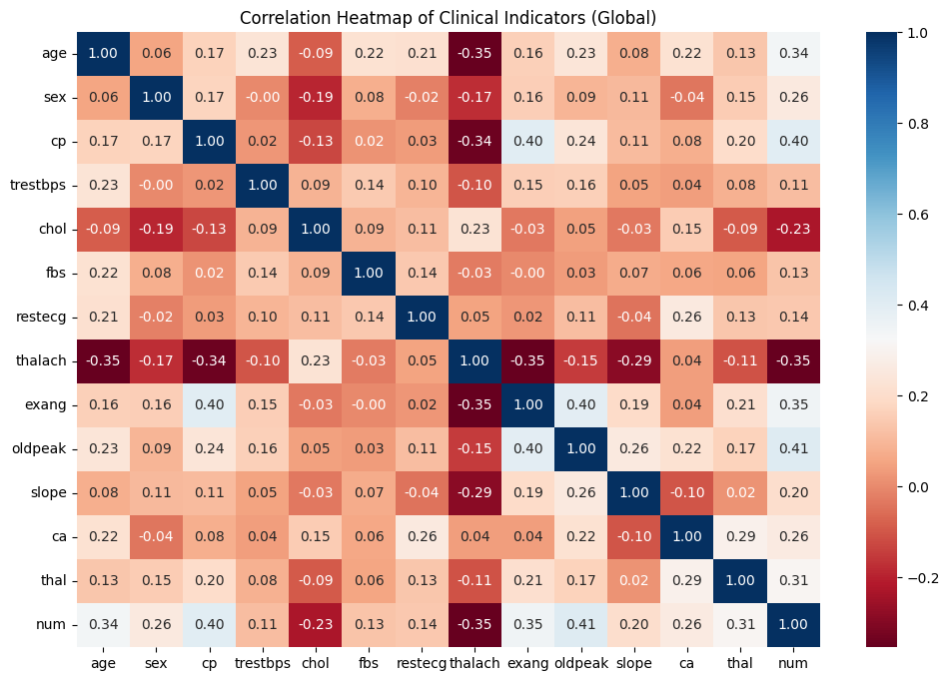
Figure 3.1: Correlation heatmap.

Heart Disease Distribution by Region
The distribution of heart disease (Figure 3.2) across different regions shows Cleveland with 164 healthy and 139 diseased people Hungary with 188 healthy and 106 diseased people Switzerland with 8 healthy and 115 diseased people and Long Beach with 51 healthy and 149 diseased people.
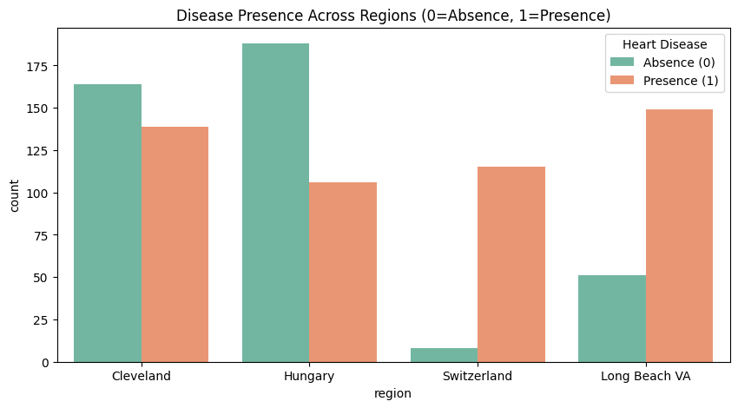
Figure 3.2: Distribution of Heart Disease

Distribution of Heart Disease Severity
Figure 3.3 displays severity counts which include 411 patients at stage 0 and 265 patients at stage 1 and 109 patients at stage 2 and 107 patients at stage 3 and 28 patients at stage 4.
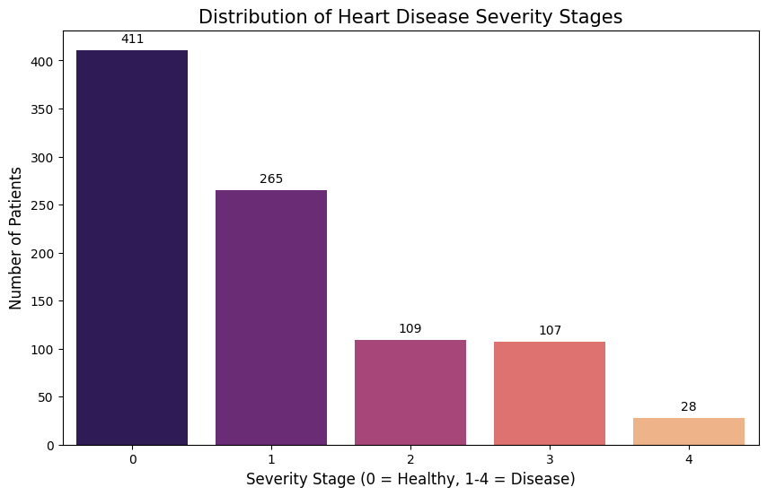Figure 3.3: Distribution of patients across heart disease severity stages
Data Preprocessing
- I used One-Hot Encoding to transform categorical data into numerical format which machine learning models could process.
- The following variables were encoded through the process: cp, restecg, slope, ca, thal, and region.
- The encoding process used the pandas get_dummies() function for execution.
- The system created separate binary columns for every category which contained values of 0 and 1.
- The system retained all category levels because drop_first was set to False.
- The encoding process increased the dataset size because it generated additional columns which would be used for model training.

Ethical Consideration

Data Privacy and Anonymization
The Heart Disease dataset does not contain identifiable personal information. The dataset replaced patient names and Social Security Number (SSN) with fake values. The dataset achieves anonymization because it prevents direct identification of any patient.

Data Usage and Licensing
The UCI Machine Learning Repository provides public access which is distributed under the Creative Commons Attribution 4.0 (CC BY 4.0) license that allows research use with proper citation.

Ethical Approval and General Data Protection Regulation
The project uses public secondary data without acquiring personal data or performing survey research. The project does not need UH ethical approval and GDPR restrictions because it does not involve personal data collection.

Ethical Data Collection
Medical researchers initially collected the dataset which they published in the American Journal of Cardiology to demonstrate their research followed ethical and credible clinical research practices.

Methodology

Overview of the Chapter
In this chapter, I discussed the methodology used for developing machine learning models for coronary heart disease prediction is explained. I also address the procedure of generating the necessary data, making machine learning models, and evaluation of the generated models. Multi-class and binary classification of heart disease were done using machine learning algorithms. Scaling of features, balancing of classes with the Synthetic Minority Over-Sampling Technique, and optimization of the model hyper parameters are also discussed in the chapter. Moreover, I the metrics that will be applied in the performance of the implemented machine learning models.

Train-Test Data Split
I divided data into two section for training I used 80 percent, whereas, for testing I used 20 percent. I further used stratified sampling to maintain an equal number of levels

Feature Scaling
In this study, feature scaling was performed using the StandardScaler for standardizing features, setting the mean to 0 and standard deviation to 1. The feature scaling process ensures that features with high values do not influence the learning process, which affects the performance of machine learning algorithms such as SVM and Logistic Regression.

Machine Learning Models
The severity of heart disease based on clinical attributes has been classified using three different algorithms.

Logistic Regression
Logistic Regression is a statistical algorithm that is applicable in classification issues. It is a model that represents the likelihood of a specific input being in a specific class based on the sigmoid function that is used to represent numbers between 0 and 1. The likelihood is given as:
$$P\left(y=1\right)=1/(1+e^{-z})$$
where z = β₀ + β₁x₁ + β₂x₂ + ... + βxₙ
Training is the process where the model is trained with the best coefficients which can be obtained by minimizing the log-loss function. It was employed as a baseline algorithm in this study because it is a simple and interpretable algorithm.

Random Forest
It is an approach of an ensemble learning algorithm that forms multiple decision trees and consolidates the outcomes of these with the assistance of the majority vote. The trees are trained using a random sample of the data and features and this minimizes overfitting and enhances generalization. It also provides the scores of the feature importance that were considered in this study as the most important clinical indicators.

Support Vector Machine (SVM).
It is used for classifying data, where the optimal hyperplane is identified which separates the different classes in the feature space in the most successful way. Non-linearly separable data are data where the data are first changed into a space with the assistance of using kernel functions. In this work, the Radial Basis Function (RBF) kernel was used which was defined as:
$$k\left(x,x_{i}\right)=exp⁡(-γ{\left|\left|x-x_{i}\right|\right|}^{2})$$
In which the effect of single training cases is regulated by γ. The best values of C and γ to optimize the classification performance were identified using hyperparameter tuning.
Table 5.1 shows the initial model configuration used in my research.
Table 5.1 Initial Model Configuration
Model | Key Parameters | Description
Logistic Regression | max_iter = 1000, class weight = balanced | Ensures model convergence and handles class imbalance
Random Forest | n_estimators = 100, random_state = 42, class_weight = balanced | Uses 100 trees for ensemble learning
Support Vector Machine | kernel = RBF, probability = True, class_weight = balanced | Nonlinear classifier using radial basis kernel

Handling Class Imbalance
The dataset contains an unequal distribution of heart disease severity classes. The training dataset was treated with Synthetic Minority Oversampling Technique (SMOTE) to solve this problem.
SMOTE creates new minority class samples by combining information from existing samples through interpolation. This technique helps prevent models from being biased toward majority classes and improves prediction performance for underrepresented categories.

Hyperparameter Optimization
The initial models required training before their hyperparameter optimization process began to enhance their predictive capabilities. The Grid Search Cross Validation method known as Grid Search Cross-Validation (GridSearchCV) allowed researchers to test various parameter combinations in a structured manner.
Grid search evaluates multiple parameter configurations and selects the combination that produces the highest classification accuracy during cross-validation.
Table 5.2 Hyperparameter Search Space
Model | Hyperparameters | Search Values
Logistic Regression | C | 0.1, 1, 10
Random Forest | n_estimators | 100, 200
 | max_depth | None, 10, 20
Support Vector Machine | C | 0.1, 1, 10
 | gamma | scale, auto
Table 5.2 displays the results of testing various parameter combinations across all models. The final model was built using the best parameter set which Grid Search determined as optimal.

Binary and Multi-Class Classification
The study implemented two different classification approaches.
Multi-class classification predicts the severity of heart disease using five classes (0–4) and Binary classification simplifies the problem by converting the target variable into two classes:
- 0
- 1
The use of binary classification allows researchers to make easier comparisons with earlier research while enhancing the understanding of their prediction outcomes.

Model Evaluation Metrics
For evaluation I used:
- Accuracy: Measures the proportion of properly classified cases.
$$Accuracy=\frac{TP+TN}{TP+TN+FP+FN}$$
- Precision: Measures the proportion of correctly predicted positive cases.
$$Precision=\frac{TP}{TP+FP}$$
- Recall: Measures the ability of the model to correctly identify positive cases.
$$Recall=\frac{TP}{TP+FN}$$
- F1-score: it is 2 times precision multiply by recall and precision plus recall. It is often called harmonic mean.
$$F1-Score=2 X \frac{Precision X Recall}{Precision+ Recall}$$
- Confusion matrices were created to display the prediction results of each model.
Where: True Positive=TP True Negative= TN, False Positive =FP, False Negative=FN

Cross-Validation
My study used 5-fold stratified cross-validation method for model assessment because it delivers dependable results. The method divides the dataset into five distinct subsets. The first subset functions as the test dataset while the model uses the remaining subsets for training.
The technique helps to prevent overfitting while establishing a reliable assessment of model efficiency throughout different data divisions.

Feature Importance Analysis
I applied Permutation Importance to check which clinical characteristics impacted the most on the accuracy of heart disease prediction. The importance of permutation is used to quantify the decrease in model accuracy when the values of a given feature are randomly permuted. The characteristics which cause the higher accuracy reduction are the most crucial factors in prediction making.

Results

Overview of the Chapter
I show the experimental outcomes which scientists obtained through their machine learning research work. The results are evaluated with accuracy, precision, recall, F1-score, and AUC to ensure a comprehensive assessment of model performance. The chapter compares the results of models. The results provide answers to my research questions which include finding the optimal classification method for heart disease detection and identifying the key medical factors which affect prediction results.

Multi-Class Model Performance (Severity Prediction)
The first experiment tested three machine learning models which handle multi-class classification for heart disease severity stages that range from 0 to 4. Table 6 .1 presents the performance comparison of the models as mentioned before.
Table 6.1 Multi-Class Model Performance (Initial Models)
Model | Accuracy | Macro Precision | Macro Recall | Macro F1-score
Logistic Regression | 0.5652 | 0.45 | 0.53 | 0.46
Random Forest | 0.5870 | 0.53 | 0.39 | 0.40
SVM | 0.5326 | 0.37 | 0.37 | 0.37
The results in Table 6.1 show that Random Forest achieved the highest accuracy of 58.7%, while Logistic Regression achieved the highest macro recall of 0.53. The overall performance stayed at a moderate level because the dataset contained class imbalances.

After Data Balancing the Multi-Class Performance Assessment
To correct the training dataset's imbalance between heart disease severity classes SMOTE oversampling was used. The performance results after balancing the system are shown in Table 6.2.
Table 6.2 displays the multi-class model performance results which were obtained after applying SMOTE.
Model | Accuracy | Macro Precision | Macro Recall | Macro F1-score
Random Forest | 0.5217 | 0.39 | 0.45 | 0.39
Logistic Regression | 0.6141 | 0.38 | 0.40 | 0.39
SVM | 0.5598 | 0.41 | 0.38 | 0.39

The results in Table 6.2 show that Random Forest achieved the highest accuracy of 61.41% after the data balancing process. The implementation of SMOTE with Random Search optimization improved class detection, but the multi-class classification task remained challenging because the severity stages showed an uneven distribution..

Optimized Binary Classification Model Performance
The prediction task became easier when the target variable was changed into two binary classes which showed the presence of heart disease as 1 and its absence as 0. The model performance improvement process used Grid Search for hyperparameter optimization. The performance comparison of optimized models appears in Table 6.3.
Table 6.3 Optimized Binary Classification Performance
Model | Accuracy | Precision | Recall | F1-Score | AUC
Random Forest | 0.8533 | 0.8504 | 0.8922 | 0.8708 | 0.9331
Logistic Regression | 0.8478 | 0.8490 | 0.8824 | 0.8653 | 0.9232
SVM | 0.8641 | 0.8407 | 0.9313 | 0.8837 | 0.9223
The results in Table 6.3 show that the Support Vector Machine (SVM) achieved its best performance with an accuracy of 86.41 percent and a recall rate of 0.9314 which demonstrates its ability to correctly identify heart disease patients.
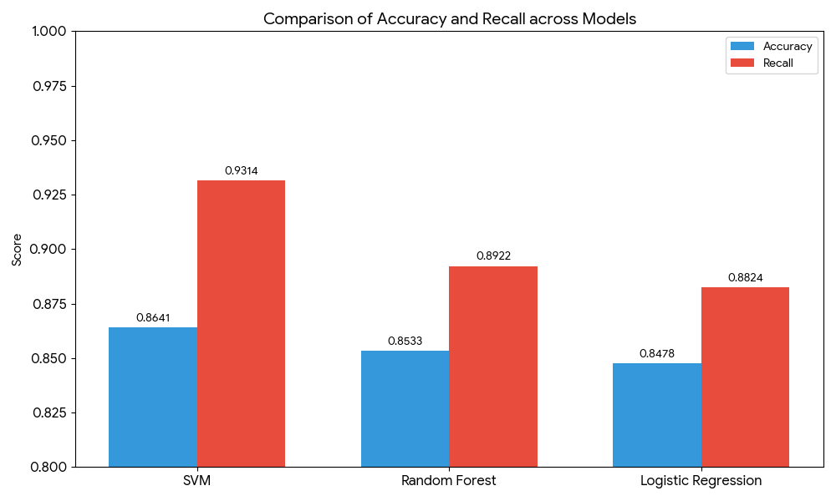
Figure 6.1: Comparison of Accuracy and Recall of models.

Confusion Matrix Analysis
Figure 6.2 shows that the model was able to correctly classify 95 cases of heart disease and 64 cases of non-disease. The model misclassified 18 healthy patients and missed 7 cases of heart disease
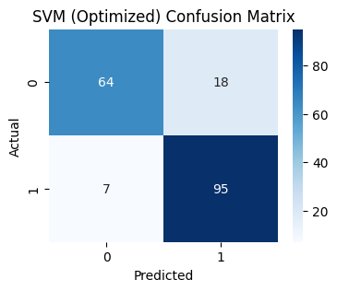

Figure 6.2: Confusion Matrix for the Optimized SVM Model
Figure 6.3 shows that the optimized Random Forest model correctly classified 91 cases of heart disease and 66 cases of non-disease. The model 16 misclassified healthy patients as diseased and missed 11 cases of heart disease
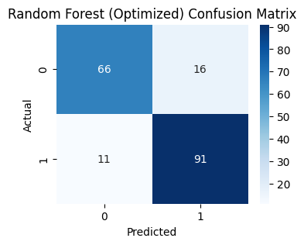
Figure 6.3: Confusion Matrix for the Optimized Random Forest Model

Similarly, Figure 6.4 shows the Confusion Matrix of Optimized Logistic Regression
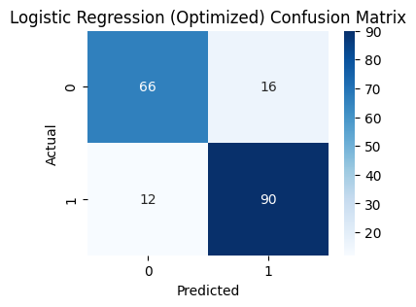
Figure 6.4: Confusion Matrix for the Optimized Logistic Regression Model

Feature Importance Analysis
The importance of features was analyzed using permutation importance, which measures the reduction in model accuracy when features are randomly permuted.
Figure 6.2 below shows that the features with the greatest impact on the model are oldpeak ≈ 0.032 and exercise induced angina ≈ 0.028. The other features with significant importance are region_Switzerland ≈ 0.022 and sex ≈ 0.013.
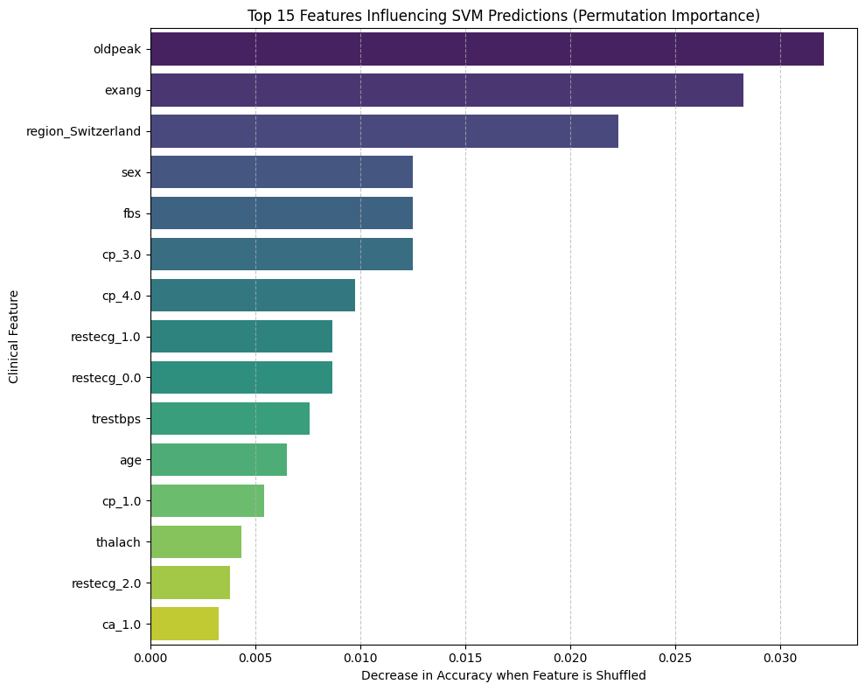
Figure 6.5 :Top 15 Clinical Features Influencing SVM Predictions

Discussion of Research Questions
- RQ1: The optimized SVM model had the best recall of 0.9314, suggesting the best sensitivity for heart disease cases.
- RQ2: The feature importance chart (Figure 6.2) suggests that oldpeak, exercise-induced angina, chest pain type, and sex are the most important features.
- RQ3: The binary classification model improved the performance significantly. The accuracy of multi-class models was 53-61%, while the accuracy of the binary models was 84-86%.

Practical Applicability of the Study
The study results show that the models are effective in the early detection of coronary heart disease using clinical features. The optimized SVM model had the best performance and can be used to assist clinicians in the early detection of coronary heart disease.

Analysis and Discussion
This chapter interprets and discusses the results obtained and presented in Chapter 6. It contain the detailed interpretation of the results including analysis, comparison with related studies and limitations.

Interpretation of Results
The experimental results show that the performance of the machine learning models depends on the classification strategy adopted and the data preparation techniques applied to the data. In the multi-class classification problem, the machine learning models achieved moderate accuracy ranging between 53% and 59%. The Random Forest model achieved the highest accuracy compared to other models. However, the performance of the models was not satisfactory because the dataset was imbalanced, with different classes having different levels of severity.
After applying SMOTE oversampling, the performance of the Random Forest model improved, with the model achieving 61% accuracy. However, the problem was not easy even after oversampling, as the machine learning model was required to predict five stages of heart disease severity.
The performance of the machine learning models improved when the target variable was converted to binary classification. After optimizing the hyperparameters of the machine learning models, the models achieved high accuracy, with all the models achieving more than 84% accuracy. The Support Vector Machine (SVM) achieved the highest accuracy of 86.41%, with a recall of 0.9314. The high performance of the SVM model indicates that it was highly effective in identifying patients with heart disease.

Model Performance Analysis
The machine learning model that performed the best compared to other models evaluated was the SVM model. The radial basis function kernel of the SVM model can handle non-linear relationships between medical variables such as cholesterol, type of chest pain, and heart rate.
The Random Forest model also gave good results because this model combines decision trees to improve the stability and accuracy of predictions. Nevertheless, the Logistic Regression model had slightly lower performance because this model is based on the linear relationship between the data and the outcome.

Comparison with Previous Studies
The findings of this study are in agreement with previous studies discussed in Chapter 2. For instance, Sayadi et al. (2022) found that Logistic Regression and SVM models had excellent performance in detecting coronary artery disease. Similarly, this study found that SVM had the best performance in terms of predictive accuracy.
However, other studies, such as Ogunpola et al. (2024), had higher accuracy values compared to this study, which used other algorithms, namely XGBoost. The accuracy values in this study may have been lower due to the number of data samples and data preprocessing techniques used.
The findings of this study concerning the importance of the model features are in agreement with medical knowledge. For instance, the study found that ST depression, denoted by oldpeak, and exercise-induced angina were the most important features in the model, and these are known to contribute to cardiovascular diseases.

Relation to RQ
The findings of this study have successfully addressed the research questions. For instance, the study found that the optimized SVM model had the best sensitivity, thus answering RQ1. Furthermore, the study found that oldpeak, exercise-induced, chest pain type, and sex were the most influential in the model, thus answering RQ2. Lastly, the findings of this study have shown that binary classification has a significant effect on model performance compared to multi-class classification, thus answering RQ3.

Limitations and Practical Implications
However, there are some limitations. First, there is a small number of samples in the data set. This could limit the overall ability for such models to generalize. Second, only three machine learning algorithms were used in this paper. Other advanced algorithms could produce even better results.
However, this paper has shown that machine learning algorithms could be used for the early detection of coronary heart disease. In a real-world setting, such models could assist doctors in detecting patients with a high risk of developing this disease.
.

Conclusion
I developed machine learning models which used clinical data to diagnose coronary heart disease. The researchers assessed three different algorithms which included Logistic Regression Random Forest and Support Vector Machine through multiple evaluation metrics. The results showed that multi-class classification achieved moderate accuracy between 53% and 61% while optimized binary classification significantly improved performance. The SVM model reached its highest performance level through an accuracy score of 86.41% and a recall score of 0.9314 which demonstrated its ability to identify heart disease cases. Feature importance analysis established that oldpeak and exercise-induced angina functioned as the primary coronary heart disease predictors.
The research demonstrates that machine learning models enable clinical decision-making by identifying patients who possess a high risk of developing heart disease. Such systems could assist healthcare professionals in early diagnosis and risk assessment using routine clinical data. The study faced limitations because of its small dataset and the researchers tested three machine learning algorithms. Future work could involve testing additional models such as XGBoost and deep learning approaches which require bigger medical datasets and the integration of the model into clinical decision support systems to enhance real-world healthcare applications.

References
Amini, M., Pursamimi, M., Hajianfar, G., Salimi, Y., Saberi, A., Mehri-Kakavand, G., Nazari, M., Ghorbani, M., Shalbaf, A., Shiri, I., & Zaidi, H. (2023). Machine learning-based diagnosis and risk classification of coronary artery disease using myocardial perfusion imaging SPECT: A radiomics study. Scientific Reports, 13(1). https://doi.org/10.1038/s41598-023-42142-w
Çakmak, A., Akyilmaz, G., Köse, A. G., Keskin, G., & Uğur, L. (2026). Machine Learning-Based Prediction of Coronary Artery Disease Using Clinical and Behavioral Data: A Comparative Study. Diagnostics, 16(2), 318. https://doi.org/10.3390/diagnostics16020318
Chen, Y., Wang, C., Liu, X., Duan, M., Xiang, T., & Huang, H. (2025). Machine learning-based coronary heart disease diagnosis model for type 2 diabetes patients. Frontiers in Endocrinology, 16. https://doi.org/10.3389/fendo.2025.1550793
Hassan, C. A. ul, Iqbal, J., Irfan, R., Hussain, S., Algarni, A. D., Bukhari, S. S. H., Alturki, N., & Ullah, S. S. (2022). Effectively Predicting the Presence of Coronary Heart Disease Using Machine Learning Classifiers. Sensors, 22(19). https://doi.org/10.3390/s22197227
Ogunpola, A., Saeed, F., Basurra, S., Albarrak, A. M., & Qasem, S. N. (2024). Machine Learning-Based Predictive Models for Detection of Cardiovascular Diseases. Diagnostics, 14(2). https://doi.org/10.3390/diagnostics14020144
Sayadi, M., Varadarajan, V., Sadoughi, F., Chopannejad, S., & Langarizadeh, M. (2022). A Machine Learning Model for Detection of Coronary Artery Disease Using Noninvasive Clinical Parameters. Life, 12(11). https://doi.org/10.3390/life12111933
Tasmurzayev, N., Baigarayeva, Z., Amangeldy, B., Imanbek, B., Kurmanbek, S., Dikhanbayeva, G., & Amirkhanova, G. (2025). Interpretable Machine Learning for Coronary Artery Disease Risk Stratification: A SHAP-Based Analysis. Algorithms, 18(11). https://doi.org/10.3390/a18110697
Zhao, S., Nan, B., Guo, J., Xu, W., & Li, Z. (2026). Coronary heart disease risk prediction based on GAIN imputation and interpretable machine learning. Frontiers in Genetics, 16. https://doi.org/10.3389/fgene.2025.1752811

Appendix




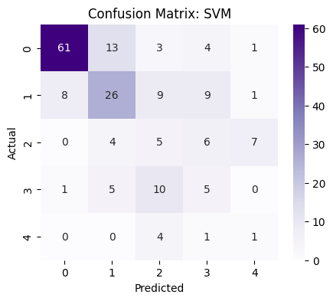
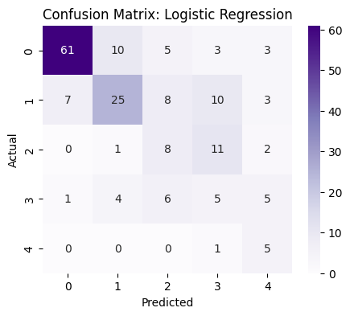
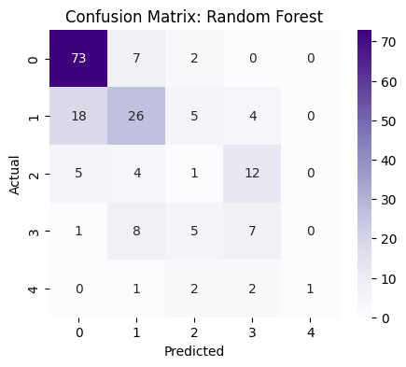
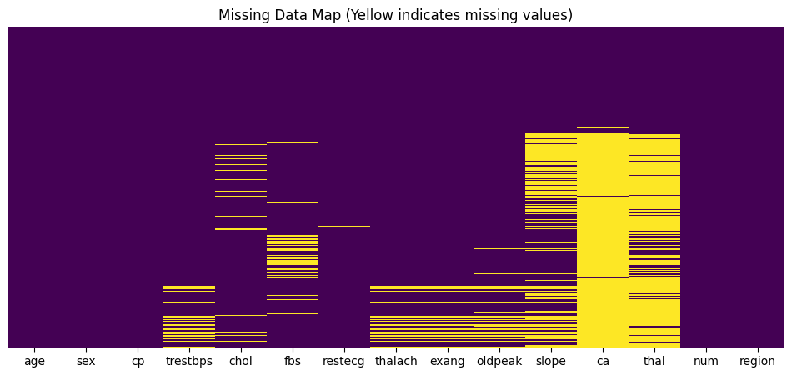

https://archive.ics.uci.edu/dataset/45/heart+disease

